CAPITAL AREA REGIONAL TOLLING AUTHORITY
STANDARD AGREEMENT

THIS AGREEMENT (“Agreement” or “Contract”), is made and entered by and between the CAPITAL AREA REGIONAL TOLLING AUTHORITY, a joint powers agency (hereinafter “CARTA”), through its duly appointed Executive Director, and _____________, a (type of entity (i.e., Corporation, Limited Liability Company, Sole Proprietorship) (hereinafter “Contractor” or “Consultant”), at Sacramento, California.

RECITALS:

1. Contractor represents that it is specially trained and/or has the experience and expertise necessary to competently perform the services set forth in this Agreement; and

2. Contractor is willing to perform the services and work described in this Agreement under the terms and conditions set forth in this Agreement; and

3. CARTA desires to contract with Contractor to perform the services and work described in this Agreement under the terms and conditions set forth in this Agreement.

NOW, THEREFORE, the parties agree as follows:

1. Time of Performance: Contractor shall commence work upon receipt of a notice to proceed from CARTA and in accordance with the Scope of Work, attached hereto as Exhibit A and incorporated herein. Contractor shall complete work as expeditiously as is consistent with generally accepted standards of professional skill and care and the orderly progress of work. Work shall be completed and this Agreement shall expire on (end date of contract), unless otherwise terminated as provided for in this Agreement or unless extended by written amendment pursuant to Section 12 below. CARTA in its sole discretion may elect to extend this Agreement for up to two (2) additional years upon written notice to Contractor.
Contractor shall complete work in accordance with the Scope of Work, attached hereto as Exhibit A, as expeditiously as is consistent with generally accepted standards of professional skill and care and the orderly progress of work.

a. This Agreement shall go into effect on (date will be entered by CARTA upon execution), contingent upon approval by CARTA, and Contractor shall commence work after notification to proceed by CARTA’s Project Manager. This Agreement shall end on (Insert contract end date), unless extended by written amendment pursuant to Section 12 below.

b. The services provided pursuant to this Agreement shall begin upon issuance of a Notice to Proceed by CARTA to the Contractor.

2. Scope of Work: Contractor agrees to fully perform the work described in Exhibit A - Scope of Work. In the event of any inconsistency between Exhibit A and other terms and conditions of this Agreement, Exhibit A shall control. CARTA reserves the right to review and approve all work to be performed by Contractor in relation to this Agreement. Any proposed amendment to the Scope of Work must be submitted by Contractor in writing for prior review and approval by CARTA’s Executive Director or designee. Approval shall not be presumed unless such approval is made by CARTA in writing.

3. Standard of Quality: All work performed by Contractor under this Agreement shall be in accordance with all applicable legal requirements and shall meet the standard of quality ordinarily to be expected of competent professionals in Contractor’s field of expertise.

4. Compliance with Laws: Contractor shall comply with all applicable Federal, State, and local laws, codes, ordinances, regulations, orders and decrees. Contractor warrants and represents to CARTA that Contractor shall, at its own cost and expense, keep in effect or obtain at all times during the term of this Agreement, any licenses, permits, insurance and approvals that are legally required for Contractor to practice its profession or are necessary and incident to the performance of the services and work Contractor performs under this Agreement. Contractor shall provide written proof of such licenses, permits, insurance and approvals upon request by CARTA. CARTA is not responsible or liable for Contractor’s failure to comply with any or all of the requirements contained in this paragraph.

5. Consideration:

- Payment to Contractor by CARTA shall be made as set forth in Exhibit A. The amount to be paid to Contractor under this Agreement shall not exceed (Insert Amount here Dollars ($ ), unless otherwise authorized by CARTA policy or expressly authorized in writing by the CARTA Executive Director or designee. In no instance shall CARTA be liable for any payments or costs for work in excess of the authorized amount, nor for any unauthorized or ineligible costs. Contractor shall be paid at the times and in the manner set forth in this Agreement. The consideration to be paid Contractor, as provided in this Agreement, shall be in compensation for all of Contractor’s expenses incurred in the performance of work under this Agreement, including travel and per diem, unless otherwise expressly so provided.

- Cost Principles and Administrative Requirements:
- Contractor agrees that the “Contract Cost Principles and Procedures,” 48 CFR, Federal Acquisition Regulations System, Chapter 1, Part 31.000, et seq., and “Uniform Administrative Requirements, Cost Principles, and Audit Requirements for Federal Awards”, 2 CFR, Part 200, shall be used to determine the cost allowability of individual items.
- Contractor also agrees to comply with Federal procedures in accordance with 2 CFR Part 200.
- Any costs for which payment has been made to Contractor that are determined by subsequent audit to be unallowable under 48 CFR, Federal Acquisition Regulations System, Chapter 1, Part 31.000, et seq., 23 CFR, 2 CFR Part 200, Uniform Administrative Requirements, Cost Principles, and Audit Requirements for Federal Awards, or any other applicable State or Federal Regulations, are subject to repayment by Contractor to CARTA. Disallowed costs must be reimbursed to CARTA within thirty (30) days unless CARTA approves in writing an alternative repayment plan. Should Contractor fail to return disallowed costs to CARTA within thirty (30) days, CARTA is authorized to withhold payments due to Contractor from other CARTA contracts. Should Contractor fail to return disallowed costs to CARTA within thirty (30) days, CARTA is authorized to withhold payments due to Contractor from other CARTA contracts.
- Contractor shall comply with, and shall require its subcontractors to comply with, the requirements for non-State employee travel and subsistence (per diem) expenses found in the California Department of Transportation (“Caltrans”) Travel Guide, Non-State Employee Travel (referencing the current California Department of Personnel Administration rules) at the following link: https://travelpocketguide.dot.ca.gov/. Lodging rates shall not exceed rates authorized to be paid non-State employees unless written verification is supplied that such rates are not commercially available to Contractor and/or its subcontractors at the time and location required as specified in the Caltrans Travel Guide Exception Process.

- Contractor and subcontractors shall establish and maintain an accounting system conforming to Generally Accepted Accounting Principles (GAAP) which segregates and accumulates reasonable, allowable, and allocable costs and matching funds for work elements by line item and produces quarterly reports which clearly identify reimbursable costs and other expenditures and shall provide support for all invoices sent to CARTA. Contractor shall also provide CARTA with the Caltrans, Local Assistance Procedures Manual, Exhibit 10-K (Consultant Certification of Contract Costs and Financial Management System) or Letter from Cognizant Agency and a completed CARTA Standard Task Based Budget form.
(6) Contractors and subcontractors shall comply with:
23 CFR; Caltrans’ Local Assistance Procedures Manual (at http://www.dot.ca.gov/hq/LocalPrograms/lam/lapm.htm);
Caltrans’ Local Assistance Programs Guidelines (at http://www.dot.ca.gov/hq/LocalPrograms/lam/lapg.htm);
California Public Contract Code, Sections 10300 to 10334, and 10335 to 10381; and all other applicable State and Federal statutes, regulations, and guidelines or additional restrictions, limitations, conditions, or any statute enacted by the state Legislature or adopted by the California Transportation Commission that may affect the provisions, terms, or funding of this project in any manner.
(7) All subcontracts in excess of $25,000 shall contain provisions 5.b(1) through 5.b(6) above.
6. Invoicing, Costs and Payment:
a. Contractor shall submit monthly invoices in arrears to CARTA based on services provided and actual costs incurred. Each invoice shall include the following: (i) prepared on Contractor’s letterhead; (ii) signed by Contractor’s Project Manager; (iii) contain a unique invoice number; (iv) attach appropriate documentation; (v) invoice each task separately; and (vi) if subcontractors are used, include a separate invoice for each subcontractor in the required format and include a summary of all subcontractors’ invoices. Contractor invoices shall also comply with all requirements set forth in Subsection b. below including, but not limited to, Subsection b(8). Invoices for contractual work completed through June 30 of a fiscal year must be submitted by July 30. Contractor shall submit written invoices in triplicate to the CARTA as specified in Subsection b(8).The invoices shall include documentation of reimbursable expenses and other invoiced items sufficient for CARTA, in its opinion, to substantiate billings. (Attached as Exhibit I is a matrix of CARTA’s required supporting documentation for invoices.) CARTA reserves the right to withhold payment of disputed amounts.

b. Allowable Costs and Payments:

(1) The method of payment for this Agreement will be task based. The total price paid to Contractor will include compensation for all work and deliverables, including travel and equipment described in the task-based Scope of Work and Budget. No additional compensation will be paid to Contractor unless there is a change in the Scope of Work. In the instance of a change in the Scope of Work, adjustment to the total compensation will be negotiated between Contractor and CARTA. Adjustment in the total compensation will not be effective until authorized by Agreement amendment and approved by CARTA.
(2) Progress payments may be made monthly in arrears based on the percentage of task(s) completed by Contractor. If Contractor fails to submit the required deliverable items according to the schedule set forth in the Scope of Work, CARTA shall have the right to delay payment or terminate this Agreement.
(3) When tasked based costs are included in the approved Cost Proposal, Contractor shall obtain prior written approval for a revised task based budget from CARTA’s Project Manager before exceeding such estimate.
(4) Contractor shall not commence performance of work or services until this Agreement has been approved by CARTA, and notification to proceed has been issued by CARTA’s Project Manager. No payment will be made prior to approval or for any work performed prior to approval of this Agreement.
(5) Contractor will be reimbursed in accordance with Section 6(a) above
7. Independent Contractor: The Contractor, and the agents and employees of the Contractor, in the performance of this Agreement, shall act as and be independent contractors and not officers or employees or agents of CARTA. Contractor, its officers, employees, agents, and subcontractors, if any, shall have no power to bind or commit CARTA to any decision or course of action, and shall not represent to any person or business that they have such power. Contractor has and shall retain the right to exercise full control of the supervision of the services and work and over the employment, direction, compensation and discharge of all persons assisting Contractor in the performance of services under this Agreement. Contractor shall be solely responsible for all matters relating to the payment of its employees including, but not limited to, compliance with social security and income tax withholding, workers’ compensation insurance and all regulations governing such matters.

8. Termination:

a. CARTA reserves the right to terminate this Agreement upon thirty (30) calendar days’ written notice to Contractor with the reasons for termination stated in the notice. The notice shall be deemed served and effective for all purposes on the date it is deposited in the U.S. mail, certified, return receipt requested, addressed to Contractor at the address indicated in Section 17.
b. CARTA may terminate this Agreement with Contractor, should Contractor fail to perform the covenants herein contained at the time and in the manner herein provided. In the event of such termination, CARTA may proceed with the work in any manner deemed proper by CARTA. If CARTA terminates this Agreement with Contractor, CARTA shall pay Contractor the sum due to Contractor under this Agreement prior to Contractor’s failure to perform, unless the cost of completion to CARTA exceeds the funds remaining in the Agreement. In which case, the overage shall be deducted from any sum due Contractor under this Agreement and the balance, if any, shall be paid to Contractor upon demand.
c. The maximum amount for which the CARTA shall be liable if this contract is terminated is [insert total contract NTE amount] Dollar ($___).

9. Assignment: The parties understand that CARTA entered into this Agreement based on the professional expertise and reputation of Contractor. Therefore, without the prior express written consent of CARTA, this Agreement is not assignable by the Contractor either in whole or in part.

10. Binding Agreement: This Agreement shall be binding on the parties hereto, their assigns, successors, administrators, executors, and other representatives.

11. Time: Time is of the essence in this Agreement.

12. Amendments: No alteration or variation of the terms of this Agreement shall be valid unless made in writing and signed by the parties hereto, and no oral understanding or agreement not incorporated herein, shall be binding on any of the parties hereto.

13. Contractors and Subcontractors: Contractor shall not subcontract any portion of the work without the prior express written authorization of CARTA.

a. CARTA reserves the right to review and approve any contract or agreement to be funded in whole or in part using funds provided under this Agreement. Subcontractors performing any work identified in Exhibit A to this Agreement shall be competitively procured in accordance with all applicable local, state and federal laws, rules and regulations, including the Caltrans Local Assistance Program Manual. Contractor agrees to include CARTA’s Project Manager in any selection process for any subcontracted work performed under this Agreement.

b. Nothing contained in this Agreement or otherwise, shall create any contractual relation between CARTA and any subcontractor, and no subcontract shall relieve Contractor of its responsibilities and obligations hereunder. Contractor agrees to be as fully responsible to CARTA for the acts and omissions of its subcontractors and of persons either directly or indirectly employed by any of them as it is for the acts and omissions of persons directly employed by Contractor. Contractor’s obligation to pay its subcontractors is an independent obligation from CARTA’s obligation to make payments to the Contractor.
c. Contractor shall perform the work contemplated with resources available within its own organization and no portion of the work pertinent to this Agreement shall be subcontracted without written authorization by CARTA’s Project Manager, except that which is expressly identified in the approved Cost Proposal.
d. Contractor shall pay its subcontractors within fifteen (15) calendar days from receipt of each payment made to Contractor by CARTA.
e. Any subcontract in excess of $25,000 entered into as a result of this Agreement shall contain all the provisions stipulated in this Agreement to be applicable to subcontractors, including:
(1) Comply with applicable State and Federal laws that pertain to, among other things, labor standards, Non-Discrimination, the Americans with Disabilities Act, Equal Employment Opportunity, the Drug-Free Workplace Act, 48 CFR, Federal Acquisition Regulations System, Chapter 1, Part 31.000, et seq., 2 CFR, Part 200, and “Contract Cost Principles and Procedures.”

(2) Maintain at least the minimum State-required Workers’ Compensation Insurance for those employees who will perform the work or any part of it.

(3) Maintain unemployment insurance and disability insurance as required by law, along with liability insurance in an amount that is reasonable to compensate any person, firm, or corporation who may be injured or damaged by the Contractor or any subcontractor in performing work associated with this Agreement or any part of it.

(4) Retain all books, records, computer records, accounts, documentation, and all other materials pertaining to the performance of this Agreement for a period of three (3) years from the date of termination of this Agreement, or three (3) years from the conclusion or resolution of any and all audits or litigation relevant to this Agreement and any amendments, whichever is later.

(5) Permit CARTA and/or its designees, upon reasonable notice, unrestricted access to any or all books, records, computer records, accounts, documentation, and all other materials pertaining to the performance of this Agreement for the purpose of monitoring, auditing, or otherwise examining said materials.

(6) Comply with all applicable requirements of Title 49, Part 26 of the Code of Federal Regulations, as set forth in Section 31, Disadvantaged Business Enterprise Participation.

f. Any substitution of subcontractors must be approved in writing by CARTA’s Project Manager prior to the start of work by the subcontractors.
14. Indemnity: Contractor specifically agrees to indemnify, defend, and hold harmless CARTA, its directors, officers, members, agents, and employees (collectively the “Indemnitees”), from and against any and all actions, claims, demands, losses, costs, expenses, including reasonable attorneys’ fees and costs, damages, and liabilities arising out of or in any way connected with the performance of this Agreement and arising out of, pertaining to, or relating to the negligence, recklessness, or willful misconduct of Contractor. Contractor shall pay all costs and expenses that may be incurred by CARTA in enforcing this indemnity, including reasonable attorneys’ fees. The provisions of this Section shall survive the expiration, termination, or assignment of this Agreement.

15. Insurance Requirements: Contractor hereby warrants that it carries and shall maintain, at its sole cost and expense, in full force and effect during the full term of this Agreement and any extensions to this Agreement, the following described insurance coverage:

POLICY | MINIMUM LIMITS OF LIABILITY
(1) Workers’ Compensation; Employer’s Liability. | Statutory requirements for Workers’ Compensation; $1,000,000 Employer’s Liability.
(2) Comprehensive Automobile: Insurance Services Office, form #CA 0001 covering Automobile Liability, code 8 (hired autos) and code 9 (non-owned autos). | Bodily Injury/Property Damage $1,000,000 each accident.
(3) General Liability: Insurance Services Office Commercial General Liability coverage (occurrence form #CG 0001). | $2,000,000 per occurrence. If Commercial General Liability Insurance or other form with a general aggregate limit, such limit shall apply separately to this project/location or the general aggregate limit shall be twice the required occurrence limit.
(4) Errors and Omissions/Professional Liability (errors and omissions liability insurance appropriate to the Contractor’s profession as defined by CARTA). | Limit of no less than $2,000,000 per occurrence or claim.

If the Contractor maintains broader coverage and/or higher limits than the minimums shown above, CARTA requires and shall be entitled to the broader coverage and/or the higher limits maintained by the contractor. Any available insurance proceeds in excess of the specified minimum limits of insurance and coverage shall be available to the CARTA.

a. Deductibles and Self-insured Retentions: Any deductibles or self-insured retentions in excess of $5,000 must be declared to and approved by CARTA.

b. Required Provisions: The general liability and automobile liability policies are to contain, or be endorsed to contain, the following provisions:

(1) For any claims related to this Agreement, the Contractor’s insurance coverage shall be the primary insurance with respect to CARTA, its directors, officers, employees and agents. Any insurance or self-insurance maintained by CARTA, its directors, officers, employees or agents shall be in excess of the Contractor’s insurance and shall not contribute to it.

(2) Any failure by Contractor to comply with reporting or other provisions of the policies including breaches of warrants shall not affect coverage provided to CARTA, its directors, officers, employees or agents.

(3) Contractor’s insurance shall apply separately to each insured against whom claim is made or suit is brought, except with respect to the limits of the insurer’s liability.

(4) Each insurance policy required by this Agreement shall be endorsed to state that coverage shall not be suspended, voided, canceled by either party, reduced in coverage or in limits except after thirty (30) days’ prior written notice by certified mail, return receipt requested, has been given to CARTA.

(5) Contractor hereby grants to CARTA a waiver of any right to subrogation which any insurer of said Contractor may acquire against CARTA by virtue of the payment of any loss under such insurance. Contractor agrees to obtain any endorsement that may be necessary to affect this waiver of subrogation, but this provision applies regardless of whether or not CARTA has received a waiver of subrogation endorsement from the insurer.
c. Acceptability of Insurers: Insurance is to be placed with insurers with a current A.M. Best’s rating of no less than A: VII, unless otherwise approved by CARTA.

d. Certificate of Insurance and Additional Insured Requirement: Contractor shall furnish to CARTA an original Certificate of Insurance on a standard ACORD form, or other form acceptable to CARTA, substantiating the required coverages and limits set forth above and also containing the following:

(1) Thirty (30) days prior written notice to CARTA of the cancellation, non-renewal, or reduction in coverage of any policy listed on the Certificate; and

(2) The following statement with respect to the Commercial General Liability policy: “CARTA and its directors, officers, employees and agents, are made additional insureds, but only insofar as the operations under this Agreement are concerned.”

e. Contractor’s Responsibility: Nothing herein shall be construed as limiting in any way the extent to which Contractor may be held responsible for damages resulting from Contractor’s operations, acts, omissions, or negligence. Insurance coverage obtained in the minimum amounts specified above shall not relieve Contractor of liability in excess of such minimum coverage, nor shall it preclude CARTA from taking other actions available to it under this Agreement or by law including, but not limited to, actions pursuant to Contractor’s indemnity obligations.

16. Retention of Records and Audit Procedures:

a. CARTA or its designee, including but not limited to any State or Federal agency, shall have the right to review, obtain, and copy all books, records, computer records, accounts, documentation and any other materials (collectively “Records”) pertaining to performance of this Agreement, including any Records in the possession of any subcontractors, for the purpose of monitoring, auditing, or otherwise examining the Records. Such Records shall include all records of employment, employment advertisements, employment application forms, and other pertinent employment data, as well as any records pertaining to compliance with Public Contract Code 10115, et seq. and Title 21, California Code of Regulations, Chapter 21, Section 2500 et seq. (when applicable) and other matters connected with the performance of the contract pursuant to Government Code 8546.7.

b. If so directed by CARTA upon expiration of this Agreement, the Contractor shall cause all Records to be delivered to CARTA as depository.

- Contractor and its subcontractors agree to cooperate with the State and CARTA by making all appropriate and relevant project Records available for audit, inspection, and/or copying by the State, the California State Auditor, or any duly authorized representative of the State or Federal government. Such Records shall be available at all reasonable times during the term of this Agreement and for three (3) years from the date of submission of the final expenditure report by the State to FHWA.

- For the purpose of determining compliance with Public Contract Code 10115, et seq., and Title 21, California Code of Regulations, Chapter 21, Section 2500, et seq., (when applicable and other matters connected with the performance of the contract pursuant to Government Code 8546.7), Contractor, subcontractors, and CARTA shall maintain and make available for inspection all Records, and other evidence pertaining to the performance of the contract including, but not limited to, the costs of administering the Agreement.

- All parties shall make such materials available at their respective offices at all reasonable times during the contract period and for three years from the date of final payment under the Agreement. The State, State Auditor, CARTA, FHWA, or any duly authorized representative of the State or Federal Government shall have access to any books, records, and documents of Contractor and its certified public accountants (CPA) work papers that are pertinent to the Agreement, and indirect cost rates (ICR) for audit, examinations, excerpts, and transactions, and copies thereof shall be furnished if requested.

- Subcontracts in excess of $25,000 shall contain this entire Section 16.
e. Audit Review Procedures:
(1) Any dispute concerning a question of fact arising under an interim or post audit of this Agreement that is not disposed of by agreement, shall be reviewed by CARTA’s Executive Director.
(2) Not later than 30 days after issuance of the final audit report, Contractor may request a review by CARTA’s Executive Director of unresolved audit issues. The Contractor’s request for review will be submitted in writing.
(3) Neither the pendency of a dispute nor its consideration by CARTA will excuse Contractor from full and timely performance in accordance with the terms of this Agreement.
(4) Contractor and subcontractor contracts, including cost proposals and ICR, are subject to audits or reviews such as, but not limited to, a contract audit, an incurred cost audit, an ICR Audit, or a CPA ICR audit workpaper review. If selected for audit or review, the Agreement, cost proposal, ICR and related workpapers, if applicable, will be reviewed to verify compliance with 48 CFR, Part 31 and other related laws and regulations. In the instances of a CPA ICR audit work paper review it is Contractor’s responsibility to ensure Federal, State, or local government officials are allowed full access to the CPA’s workpapers including making copies as necessary. The Agreement, Cost Proposal, and ICR shall be adjusted by Contractor and approved by CARTA to conform to the audit or review recommendations. Contractor agrees that individual terms of costs identified in the audit report shall be incorporated into the Agreement by this reference if directed by CARTA at its sole discretion. Refusal by Contractor to incorporate audit or review recommendations, or to ensure that the Federal, State or local governments have access to CPA workpapers, will be considered a breach of contract terms and cause for termination of the Agreement and disallowance of prior reimbursed costs.

17. Project Managers: CARTA’s Project Manager for this Agreement is
(Insert CARTA Project Manager Name) unless CARTA otherwise informs Contractor. Any notice, report, or other communication required by this Agreement shall be mailed by first-class mail to the CARTA Project Manager at the following address:

(Insert CARTA Project Manager Name and Title)
Capital Area Regional Tolling Authority
1415 L Street, Suite 300
Sacramento, CA 95814
Telephone:
Email:

Contractor’s Project Manager for this Agreement is (Insert Vendor Project Manager). No substitution of Contractor’s Project Manager is permitted without the prior written agreement of CARTA, which agreement shall not be unreasonably withheld. With the exception of notice pursuant to Section 8 (a) above, any notice, report, or other communication to Contractor required by this Agreement shall be mailed by first-class mail to:

(Insert Vendor Project Manager Name and Title)
Company Name
Address
Phone Number
E-mail Address:

18. Successors: This Agreement shall be binding on the parties hereto, their assigns, successors, administrators, executors, and other representatives.
19. Waivers: No waiver of any breach of this Agreement shall be held to be a waiver of any prior or subsequent breach. The failure of CARTA to enforce at any time the provisions of this Agreement or to require at any time performance by the Contractor of these provisions, shall in no way be construed to be a waiver of such provisions nor to affect the validity of this Agreement or the right of CARTA to enforce these provisions.
20. Litigation: Contractor shall notify CARTA immediately of any claim or action undertaken by it or against it that affects or may affect this Agreement or CARTA, and shall take such action with respect to the claim or action as is consistent with the terms of this Agreement and the interests of CARTA.
21. National Labor Relations Board Certification: Contractor, by signing this Agreement, does swear under penalty of perjury that no more than one final unappealable finding of contempt of court by a Federal court has been issued against Contractor within the immediately preceding two-year period because of Contractor’s failure to comply with an order of a Federal court which orders Contractor to comply with an order of the National Labor Relations Board (Public Contract Code § 10296).
22. Americans with Disabilities Act (ADA) of 1990; Accessibility: By signing this Agreement, Contractor assures CARTA that it complies with the Americans with Disabilities Act (ADA) of 1990 (42 U.S.C. § 12101, et seq.), which prohibits discrimination on the basis of disability, as well as all applicable regulations and guidelines issued pursuant to the ADA including, but not limited to, those found within the Code of Federal Regulations, Title 49, parts 27, 37, and 38. Contractor also agrees that it will award no construction contract unless its plans and specifications for such facilities conform to the provisions of California Government Code section 4450 and 4454, if applicable.
23. Compliance with Non-Discrimination and Equal Employment Opportunity Laws: It is CARTA’s policy to comply with State and Federal laws and regulations including Title VI of the Civil Rights Act of 1964, Americans with Disabilities Act of 1990 (ADA) and other Federal discrimination laws and regulations (including 49 CFR Part 21 through Appendix C, 23 CFR part 200, 23 CFR part 230, 49 U.S.C. 5332, 42 U.S.C. 12101 et seq., and the Title VI Assurance executed by California under 23 U.S.C. 324 and 29 U.S.C. 794), as well as the Unruh Civil Rights Act of 1959, the California Fair Employment and Housing Act (Government Code §§ 12900 et seq.), and other California State discrimination laws and regulations. CARTA does not discriminate against any employee or applicant for employment because of race, religion (including religious dress and grooming practices) color, national origin, (includes use and possession of a driver’s license issued to persons unable to prove their presence in the United States is authorized under federal law), ancestry, disability, (including physical and mental, including HIV and AIDS) medical condition, (including genetic characteristics, cancer or a record or history of cancer), military or veteran status, marital status, sex/gender (includes pregnancy, childbirth, breastfeeding, and/or related medical conditions), age (40 and above), gender identity, gender expression, or sexual orientation pursuant to Sections 12940 et seq. of the Government Code. CARTA prohibits discrimination by its employees, contractors and consultants.

Contractor hereby certifies, under penalty of perjury under the laws of California, that it complies with, and that Contractor will require that its subcontractors comply with, the following non-discrimination and equal opportunity laws. Any failure by Contractor to comply with these provisions shall constitute a material breach of this Agreement, which may result in the termination of this Agreement or such other remedy as CARTA may deem appropriate.
a. Contractor and its subcontractors shall comply with all provisions prohibiting discrimination on the basis of race, color, or national origin of Title VI of the Civil Rights Act of 1964, as amended, 42 U.S.C. §§ 2000d, et seq., with U.S. D.O.T. regulations, “Nondiscrimination in Federally-Assisted Programs of the Department of Transportation – Effectuation of Title VI of the Civil Rights Act”, 49 C.F.R. Part 21, and with any applicable implementing Federal directives that may be issued. Title VI provides that the recipients of federal assistance will implement and maintain a policy of nondiscrimination in which no person in the State of California shall, on the basis of race, color, national origin, religion, sex, age, or disability, be excluded from participation in, denied the benefits of, or subject to discrimination under any program or activity by the recipients of federal assistance or their assignees and successors in interest.
b. Contractor and its subcontractors shall comply with all applicable equal employment opportunity (EEO) provisions of 42 U.S.C. §§ 2000e, implementing Federal regulations, and any applicable implementing Federal directives that may be issued. Contractor and its subcontractors shall ensure that applicants and employees are treated fairly without regard to their race, color, creed, sex, disability, age, or national origin.

c. Contractor and its subcontractors will act in accordance with Title VI and will not unlawfully discriminate, harass, or allow harassment, against any employee or applicant for employment because of sex, sexual orientation, race, color, ancestry, religion, religious creed, national origin, physical disability (including HIV and AIDS), mental disability, medical condition, age or marital status and shall comply with the obligations of the “Administering Agency, as set forth in Exhibit G, “Fair Employment Practices Addendum” and Exhibit H, “Non-Discrimination Assurances” attached hereto and incorporated herein by this reference. Contractor and its subcontractors will further ensure that the evaluation and treatment of their employees and applicants for employment are free from such discrimination and harassment, including the improper denial of family and medical care leave and pregnancy disability leave. Contractor and its subcontractors will comply with all applicable Federal and State employment laws and regulations including, without limitation, the provisions of the California Fair Employment and Housing Act (Government Code § 12900, et seq.) and the applicable regulations promulgated thereunder (California Code of Regulations, Title 2, § 7285.0, et seq.), as well as Title 2, California Administrative Code, Section 8103. The applicable regulations of the Fair Employment and Housing Commission implementing Government Code §§ 12990 (a-f), set forth in Chapter 5 of Division 4 of Title 2 of the California Code of Regulations, are incorporated into this Agreement by reference and made a part hereof as if set forth in full. Contractor and its subcontractors will give written notice of their obligations under this clause to labor organizations with which they have a collective bargaining or other agreement.
d. Contractor shall also comply with the Older Americans Act, as amended (42 U.S.C. 6101), prohibiting discrimination on the basis of age, Section 324 of Title 23 U.S.C., prohibiting discrimination based on gender, and section 504 of the Rehabilitation Act of 1973 (29 U.S.C. 794) and 49 CFR part 27 regarding discrimination against individuals with disabilities.
e. Contractor, with regard to the work performed by it during the Agreement, shall act in accordance with Title VI. Specifically, the Contractor shall not discriminate on the basis of race, color, national origin, religion, sex, age, or disability in the selection and retention of subcontractors, including procurement of materials and leases of equipment. The Contractor shall not participate either directly or indirectly in the discrimination prohibited by Section 21.5 of the U.S. DOT’s Regulations, including employment practices when the Agreement covers a program whose goal is employment.
f. Contractor will include the provisions of this Section 23 in all contracts to perform work funded under this Agreement.
24. Drug-Free Certification: By signing this Agreement, Contractor hereby certifies under penalty of perjury under the laws of the State of California that Contractor will comply with the requirements of the Drug-Free Workplace Act of 1990 (Government Code § 8350, et seq.) and will provide a drug-free workplace by taking the following actions:
a. Publish a statement notifying employees that unlawful manufacture, distribution, dispensation, possession, or use of a controlled substance is prohibited, and specifying actions to be taken against employees for violations.
b. Establish a Drug-Free Awareness Program to inform employees about:
(1) The dangers of drug abuse in the workplace;
(2) The person’s or the organization’s policy of maintaining a drug-free workplace;
(3) Any available counseling, rehabilitation, and employee assistance programs; and
(4) Penalties that may be imposed upon employees for drug abuse violations.
c. Every employee of Contractor who works under this Agreement shall:
(1) Receive a copy of Contractor’s Drug-Free Workplace Policy Statement; and
(2) Agree to abide by the terms of Contractor’s Statement as a condition of employment on this Agreement.
25. Union Organizing: By signing this Agreement, Contractor hereby acknowledges the applicability of Government Code § 16645 through § 16649 to this Agreement, excluding § 16645.2 and § 16645.7.
a. Contractor will not assist, promote, or deter union organizing by employees performing work on this Agreement if such assistance, promotion, or deterrence contains a threat of reprisal or force, or a promise of benefit.
b. Contractor will not meet with employees or supervisors on CARTA or State property if the purpose of the meeting is to assist, promote or deter union organizing, unless the property is equally available to the general public for meetings.
26. Debarment, Suspension, and Other Responsibilities: Contractor certifies and warrants that neither the Contractor firm nor any owner, partner, director, officer, or principal of Contractor, nor any person in a position with management responsibility or responsibility for the administration of funds:
a. Is presently debarred, suspended, proposed for debarment, declared ineligible, or voluntarily excluded from covered transactions by any Federal or State department or agency.
b. Has within the three-year period preceding this Agreement, been convicted of or had a civil judgment rendered against it for commission of fraud or a criminal offense in connection with obtaining, attempting to obtain, or performing a public (Federal, State, or local) transaction or contract; violation of Federal or State antitrust statutes; or commission of embezzlement, theft, forgery, bribery, falsification or destruction of records, making false statements, or receiving stolen property.
c. Is presently indicted for or otherwise criminally or civilly charged by a government entity (Federal, State, or local) with commissions of any of the offenses enumerated in paragraph “b” above.
d. Has within a three-year period preceding this Agreement, had one or more public transactions or contracts (Federal, State, or local) terminated for cause or default.
e. Contractor shall complete the Debarment Certification Form, attached hereto as Exhibit B.

27. Conflicts of Interest:
a. Contractor shall disclose any financial, business, or other relationship with CARTA that may have an impact upon the outcome of this Agreement, or any ensuing CARTA construction project. Contractor shall also list current clients who may have a financial interest in the outcome of this Agreement, or any ensuing CARTA construction project, which will follow.
b. Contractor hereby certifies that it does not now have, nor shall it acquire, any financial or business interest that would conflict with the performance of services under this Agreement.
c. Contractor shall immediately notify CARTA of any and all potential violations of this Section upon becoming aware of the potential violation.
- Any subcontract in excess of $25,000 entered into as a result of this contract, shall contain all of the provisions of this Section.
28. Covenant Against Contingent Fees: Contractor warrants that it has not employed or retained any company or person, other than a bona fide employee working for the Contractor, to solicit or secure this Agreement, and that it has not paid or agreed to pay any company or person, other than a bona fide employee, any fee, commission, percentage, brokerage, fee, gift, or any other consideration, contingent upon or resulting from the award or formation of this Agreement. For breach or violation of this warranty, CARTA shall have the right to annul this Agreement without liability, or at its discretion to deduct from the Agreement price or consideration, or otherwise recover, the full amount of such fee, commission, percentage, brokerage fee, gift, or contingent fee.
29. Political Reform Act Compliance: Contractor is aware and acknowledges that certain contractors that perform work for governmental agencies are "consultants" under the Political Reform Act (the "Act") (Government Code § 81000, et seq.) and its implementing regulations (2 California Code of Regulations § 18110, et seq.). Contractor agrees that any of its officers or employees deemed to be "consultants" under the Act by CARTA, as provided for in the Conflict of Interest Code for CARTA, shall promptly file economic disclosure statements for the disclosure categories determined by CARTA, to be relevant to the work to be performed under this Agreement and shall comply with the disclosure and disqualification requirements of the Act, as required by law.
30. Prohibition of Expending State or Federal Funds for Lobbying:
a. Contractor certifies, to the best of his or her knowledge or belief, that:
(1) No State or Federal appropriated funds have been paid or will be paid, by or on behalf of the Contractor, to any person for influencing or attempting to influence an officer or employee of any State or Federal agency, a Member of the State Legislature or United States Congress, an officer or employee of the Legislature or Congress, or any employee of a Member of the Legislature or Congress in connection with the awarding of any State or Federal contract, the making of any State or Federal grant, the making of any State or Federal loan, the entering into of any cooperative agreement, and the extension, continuation, renewal, amendment, or modification of any State or Federal contract, grant, loan, or cooperative agreement.
(2) If any funds other than Federally appropriated funds have been paid or will be paid to any person for influencing or attempting to influence an officer or employee of any Federal agency, a Member of Congress, an officer or employee of Congress, or any employee of a Member of Congress in connection with this Federal contract, grant, loan, or cooperative agreement, the Contractor shall complete and submit Standard Form-LLL, “Disclosure Form to Report Lobbying,” in accordance with its instructions, attached hereto as Exhibit J.
b. This certification is a material representation of fact upon which reliance was placed when this Agreement was entered into. Submission of this certification is a prerequisite for making or entering into this Agreement imposed by Section 1352, Title 31, U.S. Code. Any person who fails to file the required certification shall be subject to a civil penalty of not less than $10,000 and not more than $100,000 for each such failure.
c. Contractor also agrees by signing this Agreement that he or she shall require that the language of this certification be included in all lower tier subcontracts, which exceed $100,000, and that all such sub-recipients shall certify and disclose accordingly.
31. Prompt Payments Subcontractors:
(1) Contractor agrees to pay each subcontractor under this Agreement for satisfactory performance of its contract no later than 15 days from the receipt of each payment Contractor receives from CARTA. Any delay or postponement of payment from the above-referenced time frame may occur only for good cause following written approval of CARTA.
(2) Contractor agrees to return retainage payments to each subcontractor within 15 days after the subcontractor’s work is satisfactorily completed. Any delay or postponement of payment from the above-referenced time frame may occur only for good cause following written approval of CARTA. Pursuant to 49 CFR Section 26.29, a subcontractor’s work will be deemed satisfactorily completed when all the tasks called for in the subcontract have been accomplished and documented as required by CARTA. If CARTA makes an incremental acceptance of a portion of the work hereunder, the work of a subcontractor covered by that acceptance will be deemed satisfactorily completed.
In the event Contractor fails to promptly return retainage as specified above, CARTA shall consider it a breach of this Agreement, which may result in the termination of this Agreement or other such remedy as CARTA deems appropriate including, but not limited to, administrative sanctions or penalties, including the remedies specified in Section 7108.5 of the California Business and Professions Code.
- The foregoing requirements shall not be construed to limit or impair any contractual, administrative, or judicial remedies otherwise available to Contractor or subcontractor in the event of a dispute involving late payment or non-payment to the Contractor or deficient subcontract performance or noncompliance by a subcontractor.

- Contractor’s failure to comply with any requirement of this Section is a material breach of this Agreement, which may result in the termination of this Agreement or such other remedy as CARTA may deem appropriate.
Any subcontract entered into as a result of this Agreement shall contain all of the provisions of this section.
32. Campaign Contribution Disclosure: Contractor has complied with the campaign contribution disclosure provisions of the California Levine Act (Government Code § 84308) and has completed the Levine Act Disclosure Statement attached hereto as Exhibit D.
33. Costs and Attorneys’ Fees: If either party commences any legal action against the other party arising out of this Agreement or the performance thereof, the prevailing party in such action may recover its reasonable litigation expenses, including court costs, expert witness fees, discovery expenses, and reasonable attorneys’ fees.
34. Governing Law and Choice of Forum: This Agreement shall be administered and interpreted under California law as if written by both parties. Any litigation arising from this Agreement shall be brought in the Superior Court of Sacramento County.
35. Integration: This Agreement represents the entire understanding of CARTA and Contractor as to those matters contained herein and supersedes all prior negotiations, representations, or agreements, both written and oral. This Agreement may not be modified or altered except in accordance with Section 12.
36. Severability: If any term or provision of this Agreement or the application thereof to any person or circumstance shall, to any extent, be invalid or unenforceable, the remainder of this Agreement, or the application of such term or provision to persons or circumstances other than those to which it is invalid or unenforceable, shall not be affected thereby, and each term and provision of this Agreement shall be valid and shall be enforced to the fullest extent permitted by law, unless the exclusion of such term or provision, or the application of such term or provision, would result in such a material change so as to cause completion of the obligations contemplated herein to be unreasonable.

37. Headings: The headings of the various sections of this Agreement are intended solely for convenience of reference and are not intended to explain, modify, or place any interpretation upon any of the provisions of this Agreement.

38. Authority: Each person signing this Agreement on behalf of a party hereby certifies, represents, and warrants that he or she has the authority to bind that party to the terms and conditions of this Agreement.

39. Ownership; Permission:

a. Contractor agrees that all work products including, but not limited to, notes, designs, drawings, reports, memoranda, and all other tangible personal property produced in the performance of this Agreement, shall be the sole property of CARTA, provided that Contractor may retain file copies of said work products. Contractor shall provide said work products to CARTA upon request.

b. Contractor represents and warrants that: (i) all materials used or work products produced in the performance of this Agreement, including, without limitation, all computer software materials and all written materials, are either owned by or produced by Contractor or that all required permissions and license agreements have been obtained and paid for by Contractor; and (ii) CARTA is free to use, reuse, publish or otherwise deal with all such materials or work products except as otherwise specifically provided in Exhibit A. Contractor shall defend, indemnify and hold harmless CARTA and its directors, officers, employees, and agents from any claim, loss, damage, cost, liability, or expense to the extent of any violation or falsity of the foregoing representation and warranty.

40. Counterparts: This Agreement may be executed in multiple counterparts, each of which shall constitute an original, and all of which taken together shall constitute one and the same instrument. Documents executed, scanned, and transmitted electronically and electronic signatures shall be deemed original signatures for purposes of this Agreement and all matters related thereto, with such scanned and electronic signatures having the same legal effect as original signatures.

41. Payee Data Record Form: Contractor shall complete the Payee Data Record form attached to this Agreement as Exhibit E, in lieu of IRS W-9, so that CARTA may submit payment information to its auditor/treasurer (Sacramento County).

42. Rebates, Kickbacks, or Other Unlawful Consideration: Contractor warrants that this Agreement was not obtained or secured through rebates, kickbacks or other unlawful consideration, either promised or paid to any CARTA employee. For breach or violation of this warranty, CARTA shall have the right, in its discretion: to terminate this Agreement without liability; to pay only for the value of the work actually performed; or to deduct from the Agreement price, or otherwise recover the full amount of such rebate, kickback or other unlawful consideration.

43. Equipment Purchase:

a. Prior authorization in writing, by CARTA’s Project Manager shall be required before Contractor enters into any unbudgeted purchase order, or subcontract exceeding $5,000 for supplies, equipment, or Contractor services. Contractor shall provide an evaluation of the necessity or desirability of incurring such costs.
b. For purchase of any item, service or consulting work not covered in Contractor’s Cost Proposal and exceeding $5,000 prior authorization by CARTA’s Project Manager, three competitive quotations must be submitted with the request, or the absence of bidding must be adequately justified.
c. Any equipment purchased as a result of this contract is subject to the following: “Contractor shall maintain an inventory of all nonexpendable property. Nonexpendable property is defined as having a useful life of at least one year and an acquisition cost of $5,000 or more. If the purchased equipment needs replacement and is sold or traded in, CARTA shall receive a proper refund or credit at the conclusion of the contract, or if the contract is terminated, Contractor may either keep the equipment and credit CARTA in an amount equal to its fair market value, or sell such equipment at the best price obtainable at a public or private sale, in accordance with established CARTA procedures, and credit CARTA in an amount equal to the sales price. If Contractor elects to keep the equipment, fair market value shall be determined at Contractor’s expense, on the basis of a competent independent appraisal of such equipment. Appraisals shall be obtained from an appraiser mutually agreeable to CARTA and Contractor, and if it is determined to sell the equipment, the terms and conditions of such sale must be approved in advance by CARTA.” 2 CFR Part 200 requires a credit to Federal funds when participating equipment with a fair market value greater than $5,000 is credited to the project.
d. All subcontracts in excess $25,000 shall contain the above provisions.

44. State Prevailing Wage Rates: If the Scope of Work is for a public works project pursuant to California Labor Code Section 1720, et seq., including surveying work, then the following provisions apply:
a. Contractor shall comply with the State of California’s General Prevailing Wage Rate requirements in accordance with California Labor Code, Section 1770, and all Federal, State, and local laws and ordinances applicable to the work.
b. Any subcontract entered into as a result of this contract, if for more than $25,000 for public works construction or more than $15,000 for the alteration, demolition, repair, or maintenance of public works, shall contain all of the provisions of this Section.
c. When prevailing wages apply to the services described in the Scope of Work, transportation and subsistence costs shall be reimbursed at the minimum rates set by the Department of Industrial Relations (DIR) as outlined in the applicable Prevailing Wage Determination. See http://www.dir.ca.gov.

45. Clean Air Act: Contractor agrees to comply with all applicable standards, orders or regulations issued pursuant to the Clean Air Act, as amended, including sections 174 and 176, subdivisions (c) and (d) (42 U.S.C. §§ 7504, 7506 (c) and (d)) and 40 CFR part 93 (“Clean Air requirements”). Contractor agrees to report each Clean Air requirement violation to CARTA and understands and agrees that CARTA will, in turn, report each Clean Air requirement violation as required to assure notification to FTA and the appropriate EPA Regional Office. Contractor also agrees to include these requirements in each subcontract exceeding $100,000 financed in whole or in part with Federal assistance provided by FTA.

46. Disputes: Any dispute, other than audit, concerning a question of fact arising under this Agreement that is not disposed of by agreement shall be submitted in writing to a committee consisting of CARTA’s Contracts Administrator and General Counsel. This Committee may consider the written information or additional verbal information submitted by Contractor at the request of the Committee. A determination shall be made by the Committee within 10 business days. In the event that Contractor disputes the Committee’s determination, Contractor may request review by CARTA’s Executive Director of unresolved claims or disputes, other than audit, not later than 30 days after completion of all work under the Agreement. The Contractor’s request for review must be submitted in writing. Neither the pendency of a dispute, nor its consideration by the Committee, will excuse Contractor from full and timely performance in accordance with this Agreement.

47. Confidentiality of Data:

- All financial, statistical, personal, technical, or other data and information relative to CARTA’s operations, which are designated confidential by CARTA and made available to Contractor in order to carry out this Agreement, shall be protected by Contractor from unauthorized use and disclosure.

- Permission to disclose information on one occasion, or public hearing held by CARTA relating to the contract, shall not authorize Contractor to further disclose such information, or disseminate the same on any other occasion.

- Contractor shall not comment publicly to the press or any other media regarding this Agreement or CARTA’s actions on the same, except to CARTA’s staff, Contractor’s own personnel involved in the performance of this contract, or in response to questions from a Legislative committee.

- Contractor shall not issue any news release or public relations item of any nature, whatsoever, regarding work performed or to be performed under this contract without prior review of the contents thereof by CARTA, and receipt of CARTA’S written permission.

- Any subcontract entered into as a result of this contract shall contain all of the provisions of this Section.

- All information related to cost estimates is confidential, and shall not be disclosed by Contractor to any entity other than CARTA.

48. Evaluation of Contractor Performance: Contractor’s performance may be evaluated by CARTA. A copy of the evaluation will be sent to Contractor for comments. The evaluation together with the comments shall be retained as part of the contract file.

49. Recovered Materials: The consultant agrees to comply with all the requirements of Section 6002 of the Resource Conservation and Recovery Act (RCRA), as amended (42 U.S.C. 6962), including but not limited to the regulatory provisions of 40 CFR Part 247, and Executive Order 12873, as they apply to the procurement of the items designated in Subpart B of 40 CFR Part 247. The consultant agrees to comply with the U.S. Environmental Protection Agency (US EPA), “Comprehensive Procurement Guideline for Products Containing Recovered Materials,” 40 CFR part 247.

50. Program Fraud and False or Fraudulent Statements or Related Acts:

  - The Consultant acknowledges that the provisions of the Program Fraud Civil Remedies Act of 1986, as amended, 31 U.S.C. §§ 3801 et seq. and U.S. DOT regulations, "Program Fraud Civil Remedies," 49 C.F.R. Part 31, apply to its actions pertaining to this Project. Upon execution of the underlying contract, the Consultant certifies the truthfulness and accuracy of any statement it has made, it makes, it may make, or causes to be made, pertaining to the underlying contract or the FTA assisted project for which this contract work is being performed. In addition to other penalties that may be applicable, the Consultant further acknowledges that if it makes, or causes to be made, a false, fictitious, or fraudulent claim, statement, submission, or certification, the Federal Government reserves the right to impose the penalties of the Program Fraud Civil Remedies Act of 1986 on the Consultant to the extent the Federal Government deems appropriate.

  - The Consultant also acknowledges that if it makes, or causes to be made, a false, fictitious, or fraudulent claim, statement, submission, or certification to the Federal Government under a contract connected with a project that is financed in whole or in part with Federal assistance originally awarded by FTA under the authority of 49 U.S.C. § 5307, the Government reserves the right to impose the penalties of 18 U.S.C. § 1001 and 49 U.S.C. § 5307(n)(1) on the Consultant, to the extent the Federal Government deems appropriate.

  - The Consultant agrees to include the above two (2) clauses in each subcontract financed in whole or in part with Federal assistance provided by FTA. It is further agreed that the clauses shall not be modified, except to identify the sub-consultant who will be subject to the provisions.

51. Funding Requirements:

a. It is mutually understood between the parties that this Agreement may have been written before ascertaining the availability of funds or appropriation of funds, for the mutual benefit of both parties, in order to avoid program and fiscal delays that would occur if the contract were executed after that determination was made.

b. This Agreement is valid and enforceable only, if sufficient funds are made available to CARTA for the purpose of this Agreement. In addition, this Agreement is subject to any additional restrictions, limitations, conditions, or any statute enacted by the Congress, State Legislature, or CARTA’s governing Board that may affect the provisions, terms, or funding of this Agreement in any manner.

c. It is mutually agreed that if sufficient funds are not appropriated, this Agreement may be amended to reflect any reduction in funds.

d. CARTA has the option to void the contract under the 30-day termination clause pursuant to Section 8 of this Agreement, or by mutual agreement to amend the contract to reflect any reduction of funds.

52. Prohibition on Providing or Using Certain Telecommunications and Video Surveillance Services or Equipment: Consistent with Section 889 of the John S. McCain National Defense Authorization Act for Fiscal Year 2019, Pub. L. 115-232 (Aug. 13, 2018), CONTRACTOR must not: (a) provide “covered telecommunications equipment or services” (as that term is defined in Section 889 of the Act) as part of its performance under this Contract, if such equipment or services will be used as a substantial or essential component of any system or as critical technology as part of any system; or (b) use such covered telecommunication equipment or services as a substantial or essential component of any system or as critical technology as part of any system, regardless of whether that use is in connection with performance of work under this Contract, subject only to the exception that covered telecommunications equipment or services may be provided or used if the equipment or services cannot route or redirect user data traffic or permit visibility into any user data or packets that such equipment transmits or otherwise handles.

53. Notification to FTA; Flow Down Requirement: If a current or prospective legal matter that may affect the Federal Government emerges, the Contractor must promptly notify CARTA, which will promptly notify the FTA Chief Counsel and FTA Regional Counsel for the Region in which CARTA is located. The Contractor must include an equivalent provision in its subagreements at every tier, for any agreement that is a “covered transaction” according to 2 C.F.R. §§ 180.220 and 1200.220.

- The types of legal matters that require notification include, but are not limited to, a major dispute, breach, default, litigation, or naming the Federal Government as a party to litigation or a legal disagreement in any forum for any reason.

- Matters that may affect the Federal Government include, but are not limited to, the Federal Government’s interests in the Award, the accompanying Underlying Agreement between the FTA and CARTA, and any Amendments thereto, or the Federal Government’s administration or enforcement of federal laws, regulations, and requirements.

- Additional Notice to U.S. DOT Inspector General. The Contractor must promptly notify CARTA, which will promptly notify the U.S. DOT Inspector General in addition to the FTA Chief Counsel or Regional Counsel for the Region in which CARTA is located, if the Contractor has knowledge of potential fraud, waste, or abuse occurring on a Project receiving assistance from FTA. The notification provision applies if a person has or may have submitted a false claim under the False Claims Act, 31 U.S.C. § 3729, et seq., or has or may have committed a criminal or civil violation of law pertaining to such matters as fraud, conflict of interest, bid rigging, misappropriation or embezzlement, bribery, gratuity, or similar misconduct involving federal assistance. This responsibility occurs whether the Project is subject to this Agreement or another agreement with CARTA involving a principal, officer, employee, agent, or Third-Party Participant of the Contractor. It also applies to subcontractors at any tier. Knowledge, as used in this paragraph, includes, but is not limited to, knowledge of a criminal or civil investigation by a Federal, state, or local law enforcement or other investigative agency, a criminal indictment or civil complaint, or probable cause that could support a criminal indictment, or any other credible information in the possession of the Contractor. In this paragraph, “promptly” means to refer information without delay and without change. This notification provision applies to all divisions of the Contractor, including divisions tasked with law enforcement or investigatory functions.

54. Economic Sanctions: Pursuant to California State Executive Order N-6-22 (Order) imposing economic sanctions against Russia and declaring support of Ukraine, CARTA shall terminate any contract with any individual or entity that is in violation of the Order or that is subject to economic sanctions therein, and shall not enter a contract with any such individual or entity while the Order is in effect.

55. United States-flag Vessels: Per 46 CFR 381, Use of United States-flag vessels, the contractor agrees:

- To utilize privately owned United States-flag commercial vessels to ship at least 50 percent of the gross tonnage (computed separately for dry bulk carriers, dry cargo liners, and tankers) involved, whenever shipping any equipment, material, or commodities pursuant to this contract, to the extent such vessels are available at fair and reasonable rates for United States-flag commercial vessels.

- To furnish within 20 days following the date of loading for shipments originating within the United States or within 30 working days following the date of loading for shipments originating outside the United States, a legible copy of a rated, “on-board” commercial ocean bill-of-lading in English for each shipment of cargo described in paragraph (b) (1) of this section to both the Contracting Officer (through the prime contractor in the case of subcontractor bills-of-lading) and to the Division of National Cargo, Office of Market Development, Maritime Administration, Washington, DC 20590.

- To insert the substance of the provisions of this clause in all subcontracts issued pursuant to this contract.

(Signature Page to Follow)

IN WITNESS WHEREOF, THE PARTIES HAVE ENTERED INTO THIS AGREEMENT AS OF THE DATE HEREIN ABOVE APPEARING:

CAPITAL AREA REGIONAL TOLLING AUTHORITY

________________________________________
JAMES CORLESS
Secretary

APPROVED AS TO FORM:

________________________________________
SLOAN SAKAI YEUNG & WONG, LLP
Legal Counsel to CARTA

RECOMMENDED BY:

________________________________________
NAME
Title

CONTRACTOR COMPANY:

________________________________________
NAME
Title

EXHIBIT “A”

(SAMPLE) Scope of Work and Budget

(Include description of each bullet point below)

(Include detailed description of terms of payment, e.g., specify fixed amount with no reimbursable costs, specify hourly rate with identified reimbursable costs up to a “not to exceed” figure)

Introduction

(Insert Project Description)

Tasks
Task 1: Task Title
Task 1.1:(enter subtasks if appropriate)
Task 1.2:

Deliverables:
- Enter Deliverable 1
- Enter Deliverable 2 etc.

Completion date:
Task 1 Cost:

Task 2: Task Title
Task 2.1:(enter subtasks if appropriate)
Task 2.2:

Deliverables:
- Enter Deliverable 1
- Enter Deliverable 2 etc.

Completion date:
Task 2 Cost:

Budget

The total amount to be paid to Contractor under this Agreement, in accordance with this Scope of Work and Budget, shall not exceed ___________ Dollars ($__________), unless expressly authorized in writing by the CARTA Executive Director or designee.

Level of Effort
Project Staff | Rate | Hours | Total Cost
Task 1
Task 2

Optional Extension: An optional two-year extension may be exercised if agreed upon by CARTA and Contractor. If exercised, the amount paid to contractor for the two-year extension shall not exceed Insert Amount in words Dollars ($xx,xxx.oo)unless expressly authorized in writing by the Executive Director or designee.

INSERT CARTA STANDARD AGREEMENT TASK BASED BUDGET FORM AND EXHIBIT 10-K INDRECT COSTS (OR SAFE HARBOR RATE OR LETTER FROM COGNIZANT AGENCY) HERE.

EXHIBIT B
DEBARMENT CERTIFICATION FORM

The Contractor certifies that, neither the Contractor firm nor any owner, partner, director, officer, or principal of the Contractor, nor any person in a position with management responsibility or responsibility for the administration of Federal funds:

(a) Is presently debarred, suspended, proposed for debarment, declared ineligible, or voluntarily excluded from covered transactions by any Federal or State department/agency;

(b) Has within a three-year period preceding this certification been convicted of or had a civil judgment rendered against it for: commission of fraud or a criminal offense in connection with obtaining, attempting to obtain, or performing a public transaction or contract (Federal, State, or local); violation of Federal or State antitrust statutes; or commission of embezzlement, theft, forgery, bribery, falsification or destruction of records, making false statements, or receiving stolen property;

(c) Is presently indicted for or otherwise criminally or civilly charged by a governmental entity (Federal, State, or local) with commission of any of the offenses enumerated in paragraph (b) above; or

(d) Has within a three-year period preceding this certification had one or more public transactions or contracts (Federal, State, or local) terminated for cause or default.

The Contractor further certifies that it shall not knowingly enter into any transaction with any subcontractor, material supplier, or vendor who is debarred, suspended, declared ineligible, or voluntarily excluded from covered transactions by any Federal or State department/agency.

Dated this day of , 20 __________

By______________________________________________________________
Authorized Signature for Contractor

_____________________________________________________________
Printed Name and Title

______________________________________________________________
Contractor Firm Name and Type of Entity (Corp., Partnership, Sole Proprietor)

______________________________________________________________
Address

______________________________________________________________
City/State/Zip Code

______________________________________________________________
Area Code/Telephone Number and E-Mail Address

EXHIBIT C
Intentionally Omitted
EXHIBIT D
LEVINE ACT AND GOVERNMENT CODE 1090 DISCLOSURE STATEMENTS

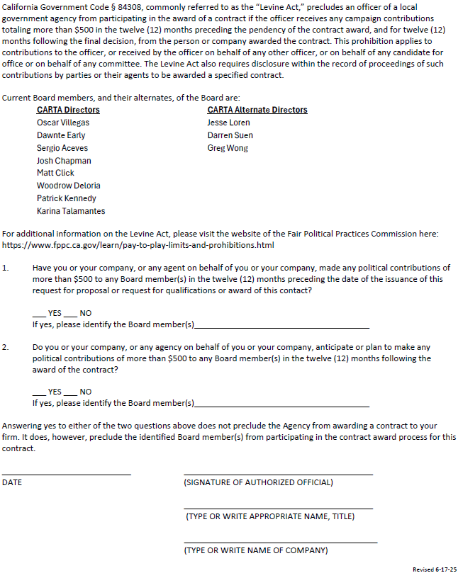
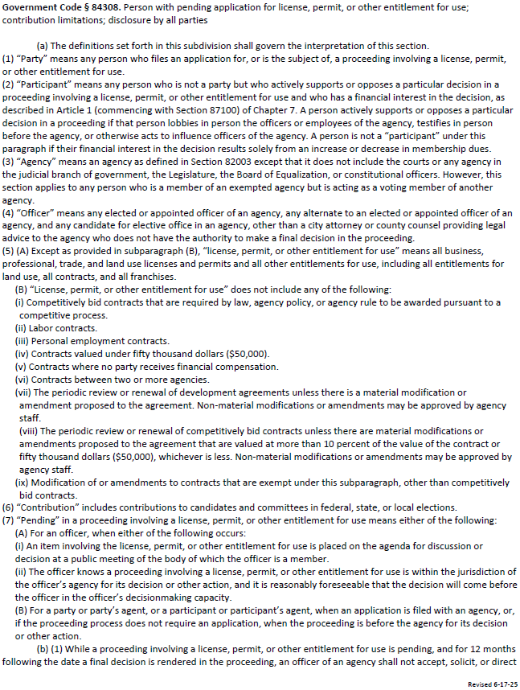
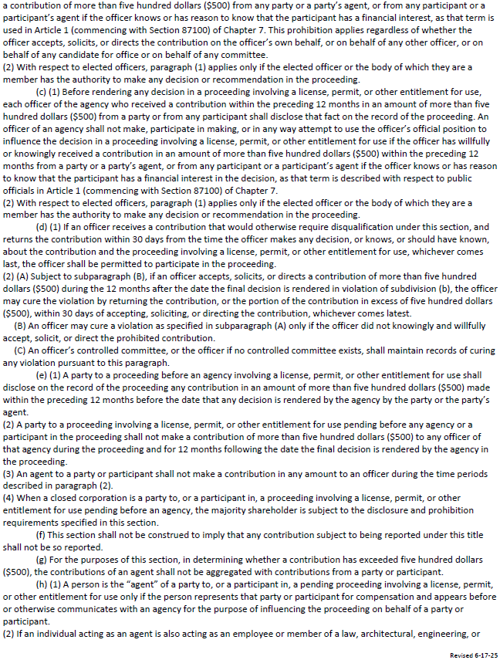

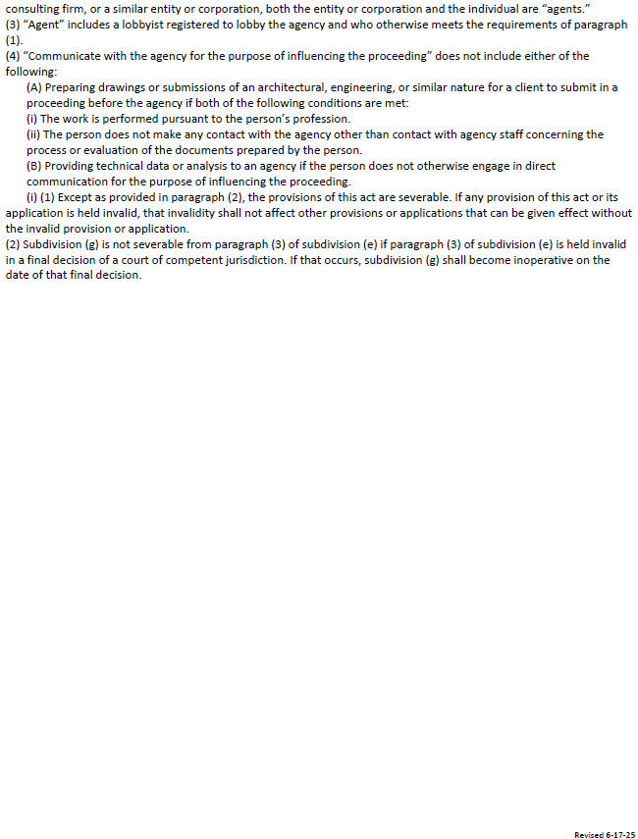
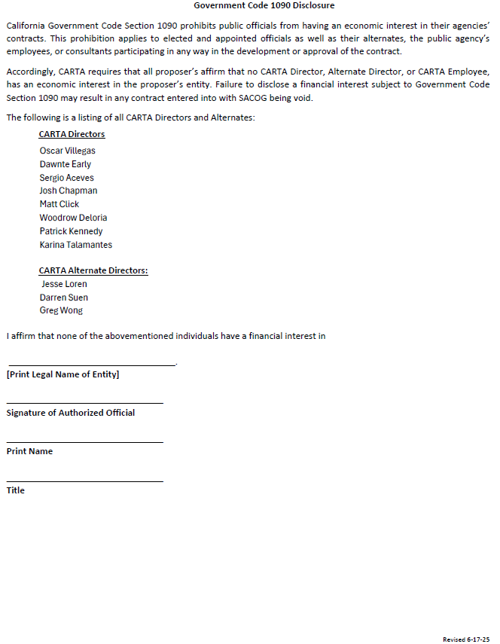

EXHIBIT E
EXHIBIT F
Intentionally Omitted

EXHIBIT G

FAIR EMPLOYMENT PRACTICES ADDENDUM

1. In the performance of this Agreement, ADMINISTERING AGENCY will not discriminate against any employee for employment because of race, color, sex, sexual orientation, religion, ancestry or national origin, physical disability, medical condition, marital status, political affiliation, family and medical care, pregnancy leave, or disability leave. ADMINISTRATION AGENCY will take affirmative action to ensure that employees are treated during employment without regard to their race, sex, sexual orientation, color, religion, ancestry or national origin, physical disability, medical condition, marital status, political affiliation, family and medical care leave, pregnancy leave, or disability leave. Such action shall include, but not be limited to, the following: employment; upgrading; demotion or transfer; recruitment or recruitment advertising; layoff or termination; rates of pay or other forms of compensation; and selection for training, including apprenticeship. ADMINISTERING AGENCY shall post in conspicuous places, available to employees for employment, notices to be provided by STATE setting forth the provisions of this Fair Employment section.

2. ADMINISTRATING AGENCY, its contractor(s) and all subcontractors shall comply with the provisions of the Fair Employment and Housing Act (Government Code Section 12900 et seq.), and the applicable regulations promulgated thereunder (California Code of Regulations, Title 2, Section 7285.0 et seq.). The applicable regulations of the Fair Employment and Housing Commission implementing Government Code, Section 12900(a-f), set forth in Chapter 5 of Division 4 of Title 2 of the California Code of Regulations are incorporated into this AGREEMENT by reference and made a part hereof as if set forth in full. Each of the ADMINISTERING AGENCY’s contractors and all subcontractor shall give written notice of their obligations under this clause to labor organizations with which they have a collective bargaining or other agreements, as appropriate.

3. ADMINISTERING AGENCY shall include the nondiscrimination and compliance provisions of this clause in all contracts and subcontracts to perform work under this AGREEMENT.

4. ADMINISTERING AGENCY will permit access to the records of employment, employment advertisements, application forms, and other pertinent data and records by STATE, the State Fair Employment and Housing Commission, or any other agency of the State of California designated by STATE, for purposes of investigation to ascertain compliance with the Fair Employment section of this AGREEMENT.

5. Remedies for Willful Violation:

(a) STATE may determine a willful violation of the Fair Employment provision to have occurred upon receipt of a final judgment to that effect from a court in an action to which ADMINISTERING AGENCY was a party or upon receipt of a written notice from the Fair Employment and Housing Commission that it has investigated and determined that ADMINISTERING AGENCY has violated the Fair Employment Practices Act and had issued an order under Labor Code Section 1426 which has become final or has obtained an injunction under Labor Code Section 1429.
(b) For willful violation of this Fair Employment provision, STATE shall have the right to terminate this AGREEMENT either in whole or in part, and any loss or damage sustained by STATE in securing the goods or services thereunder shall be borne and paid for by ADMINISTERING AGENCY and by the surety under the performance bond, if any, and STATE may deduct from any monies due or thereafter may become due to ADMINISTERING AGENCY, the difference between the price named in the Agreement and the actual cost thereof to STATE to cure ADMINISTERING AGENCY’s breach of this Agreement.

EXHIBIT H

NONDISCRIMINATION ASSURANCES

ADMINISTERING AGENCY HEREBY AGREES THAT, a condition to receiving any Federal financial assistance from the STATE, acting for the U.S. Department of Transportation, it will comply with Title VI of the Civil Rights Act of 1964, 78 Stat. 252, 42 U.S.C. 2000d-42, U.S.C. 2000d-4 (hereinafter referred to as the ACT), and all requirements imposed by or pursuant to Title 49, Code of Federal Regulations, Department of Transportation, Subtitle A, Office of the Secretary, Part 21, “Nondiscrimination in Federally-Assisted Programs of the Department of Transportation – Effectuation of Title VI of the Civil Rights Act of 1964” (hereinafter referred to as the REGULATIONS), the Federally-aid Highway Act of 1973, and other pertinent directives, to and that in accordance with the ACT, REGULATIONS, and other pertinent directives, no person in the United States shall, on the grounds of race, color, sex, national origin, religion, age or disability, be excluded from participation in, be denied the benefits of, or be otherwise subjected to discrimination under any program or activity for which ADMINISTERING AGENCY receives federal financial assistance from the Federal Department of Transportation, ADMINESTERING AGENCY HEREBY GIVES ASSURANCES THAT ADMINESTERING AGENCY will promptly take any measures necessary to effectuate this AGREEMENT. This Assurance is required by subsection 21.7(a)(1) of the REGULATIONS.

More specifically, and without limiting the above general assurance, ADMINISTERING AGENCY hereby gives the following specific assurances with respect to the Federal-Assisted Program:

1. That ADMINISTERING AGENCY agrees that each ‘program” and each “facility” as defined in subsection 21.23 (e) and 21.23 (b) of the REGULATIONS, will be (with regard to a “program”) conducted, or will be (with regard to a “facility”) operated in compliance with all requirements imposed by, or pursuant to, the REGULATIONS.

2. That ADMINISTERING AGENCY shall insert the following notification in all solicitations for bids for work or material subject to the REGULATIONS made in connection with the Federal-Assisted Program and, in adapted form, in all proposals for negotiated agreements:

ADMINISTERING AGENCY hereby notifies all bidders that it will affirmatively insure that in any agreement entered into pursuant to this advertisement, minority business enterprises will be afforded full opportunity to submit bids in response to this invitation and will not be discriminated against on the grounds of race, color, sex, national origin, religion, age, or disability in consideration for an award.

3. That ADMINISTERING AGENCY shall insert the clauses of Appendix A of this Assurance in every agreement subject to the ACT and the REGULATIONS.

4. That the clauses of Appendix B of this Assurance shall be included a s covenant running with the land, in any deed affecting a transfer of real property, structures, or improvements thereon, or interest therein.

5. That where ADMINISTERING AGENCY receives federal finance assistance to construct a facility, or part of a facility, the Assurance shall extend to the entire facility and facilities operated in connection therewith.

6. That where ADMINISTERING AGENCY receives federal financial assistance in the form, or for the acquisition, of real property or an interest in real property, the Assurance shall extend to rights to space on, over, or under such property.

7. That ADMINISTERING AGENCY shall include the appropriate clauses set forth in Appendix C and D of the Assurance, as a covenant running with the land, in any future deeds, leases, permits, licenses, and similar agreements entered into by the ADMINISTERING AGENCY with other parties:

Appendix C:

(a) for the subsequent transfer of real property acquired or improved under the federal-aid Program; and

Appendix D:

(b) for the construction or use of or access to space on, over, or under real property acquired, or improved under the federal-aid Program.

8. That this Assurance obligates ADMINISTERING AGENCY for the period during which federal financing assistance is extended to the program, except where the federal financial assistance is to provide, or is in the form of personal property or real property or interest therein, or structures, or improvements thereon, in which case the Assurance obligates ADMINSTERING AGENCY or any transferee for the longer of the following periods:

(a) the period during which the property is used for a purpose for which the federal financial assistance is extended, or for another purpose involving the provision of similar services or benefits; or

(b) the period during which ADMINISTERING AGENCY retains ownership or possession of the property.

9. The ADMINISTERING AGENCY shall provide for such methods of administration for the program as are found by the U.S. Secretary of Transportation, or the official to whom he/she delegates specific authority, to give reasonable guarantee that ADMINISTERING AGENCY, other recipients, sub-grantees, applicants, sub-applicants, transferees, successors in interest, and other participants of federal financial assistance under such program will comply with all requirements imposed by, or pursuant to, the ACT, the REGULATIONS, this Assurance and the AGREEMENT.

10. That ADMINISTERING AGENCY agrees that the United States and the State of California have a right to seek judicial enforcement with regard to any matter arising under the ACT, the REGULATIONS, and this Assurance.

11. ADMINISTERING AGENCY shall not discriminate on the basis of race, religion, age, disability, color, national origin or sex in the award and performance of any STATE-assisted contract or in the administration on its DBE Program or the requirement of 49 CFR Part 26. ADMINISTERING AGENCY shall take all necessary and reasonable steps under 49 CFR Part 26 to ensure nondiscrimination in the award and administration of STATE-assisted contracts. ADMINISTERING AGENCY’s DBE Race-Neutral Implementation Agreement is incorporated by reference in this AGREEMENT. Implementation of this program is a legal obligation and failure to carry out its terms shall be treated as a violation of this Agreement. Upon notification to the recipient of its failure to carry out is approved DBE Race-Neutral Implementation Agreement, STATE may impose sanctions as provided for under 49 CFR Part 26 and may, in appropriate cases refer the matter for enforcement under 18 U.S.C 1001 and/or the Program Fraud Civil Remedies Act of 1985 (31 U.S.C. 3801 et seq.).

THESE ASSURANCES are given in consideration of and for the purpose of obtaining any and all federal grants, loans, agreements, property, discounts or other federal financial assistance extended after the date hereof to ADMINISTERING AGENCY by STATE, acting for the U.S. Department of Transportation, and is binding on ADMINISTERING AGENCY, other recipients, subgrantees, applicants, sub-applicants, transferees, successors in interest and other participants in the federal-aid Highway Program.

APPENDIX A TO EXHIBIT H

During the performance of this Agreement, ADMINISTERING AGENCY, for itself, its assignees and successors in interest (hereinafter collectively referred to as ADMINISTERING AGENCY) agree as follows:

1. Compliance with Regulations: ADMINISTERING AGENCY shall comply with the REGULATIONS relative to nondiscrimination in federally assisted programs of the Department of Transportation, Title 49, Code of Federal Regulations, Part 21, as they may be amended from time to time (hereinafter referred to as the REGULATIONS), which are incorporated by reference and made a part of this Agreement.

2. Nondiscrimination: ADMINISTERING AGENCY, with regard to the work performed by it during the AGREEMENT, shall not discriminate on the grounds of race, color, sex, national origin, religion, age, or disability in the selection and retention of subcontractors, including procurements of materials and leases of equipment. ADMINISTERING AGENCY shall not participate either directly or indirectly in the discrimination prohibited by Section 21.5 of the REGULATIONS, including employment practices when the AGREEMENT covers a program set forth in Appendix B of the REGULATIONS.

3. Solicitations for Sub-agreements, including Procurements of Materials and Equipment: In all solicitations either by competitive bidding or negotiation made by ADMINISTERING AGENCY for work to be performed under a Sub-agreement, including procurements or materials or leases of equipment, each potential sub-applicant or supplier shall be notified by ADMINISTERING AGENCY of the ADMINISTERING AGENCY’s obligations under this AGREEMENT and the REGULATION relative to nondiscrimination on the grounds of race, color, or national origin.

4. Information and Reports: ADMINISTERING AGENCY shall provide all information and reports required by the REGULATIONS, or directives issued pursuant thereto, and shall permit access to ADMINISTERING AGENCY’s books, records, accounts, other sources of information, and its facilities as may be determined by STATE or FHWA to in pertinent to ascertain compliance with such REGULATIONS or directives. Where any information required of ADMINISTERING AGENCY as in the exclusive possession of another who fails or refuses to furnish this information, ADMINISTERING AGENCY shall so certify to STATE or the FHWA as appropriate, and shall set forth what efforts ADMINISTERING AGENCY has made to obtain the information.

5. Sanctions for Noncompliance: In the event of ADMINISTERING AGENCY’s noncompliance with the nondiscrimination provisions of this AGREEMENT, STATE shall impose such AGREEMENT sanctions as it or the FHWA may determine to be appropriate, including, but not limited to:

(a) withholding of payments to ADMINISTERING AGENCY under the AGREEMENT within a reasonable period of time, not to exceed ninety (90) days; and/or

(b) cancellation, termination or suspension of the AGREEMENT, in whole or in part.

6. Incorporation of Provision: ADMINISTERING AGENCY shall include the provisions of paragraphs 1 through 6 in every sub-agreement, including procurements of materials and leases of equipment unless exempt by the REGULATIONS or directives issues pursuant thereto. ADMINISTERING AGENCY shall take such action with respect to any sub-agreement or procurement as STATE or FHWA may direct as a means of enforcing such provisions, including sanctions for noncompliance provided; however, that, in the event ADMINISTERING AGENCY becomes involved in, or is threatened with, litigation with a sub-applicant or supplier as a result of such direction, ADMINISTERING AGENCY may request STATE enter into such litigation to protect the interests of the STATE, and, in addition, ADMINSTERING AGENCY may request the United States to enter into such litigation to protect the interests of the United States.

APPENDIX B TO EXHIBIT H

The following clauses shall be included in any and all deeds affecting or recording the transfer of PROJECT real property; structures or improvements thereon, or interest therein from the United States.

(GRANTING CLAUSE)

NOT, THEREFORE, the U.S. Department of Transportation, as authorized by law, and upon the condition that ADMINISTERING AGENCY will accept title to the lands and maintain the Project constructed thereon, in accordance with Title 23, United States Code, the Regulations for the Administration of Federal-aid for Highways and the policies and procedures prescribed by the Federal Highway Administration of the Department of Transportation and, also in accordance with, and in compliance with, Regulations pertaining to and effectuating the provisions of Title VI of the Civil Rights Act of 1964 (78 Stat. 252; 42 U.S.C. 2000d to 2000d-4), does hereby remiss, release, quitclaim and convey unto the ADMINISTERING AGENCY all the right, title, and interest of the U.S. Department of Transportation in, and to, said and described in Exhibit “A” attached hereto and made a part hereof.
(HABENDUM CLAUSE)

TO HAVE AND TO HOLD said lands and interests therein unto ADMINISTERING AGENCY and its successors forever, subject; however, to the covenant, conditions, restrictions and reservations herein contained as follows, which will remain in effect for the period during which the real property or structures are used for a purpose for which federal financial assistance is extended or for another purpose involving the provision of similar services or benefits and shall be binding on ADMINISTERING AGENCY, its successors and assigns.

ADMINISTERING AGENCY, in consideration of the conveyance of said lands and interests in lands, does hereby covenant and agree as a covenant running with the land to itself, its successors and assigns.

1. That no person shall on the grounds of race, color, sex, national origin, religion, age or disability, be excluded from participation in, be denied the benefits of, or otherwise subjected to discrimination with regard to any facility located wholly or in part on, over, or under such lands hereto conveyed(:) (and)

2. That ADMINISTERING AGENCY shall use the lands and interests in lands so conveyed, in compliance with all requirements by or pursuant to Title 49, Code of Federal Regulations, Department of Transportation, Subtitle A, Office of the Secretary, Part 21, Non-discrimination in federally-assisted programs of the Department of Transportation – Effectuation of Title VI of the Civil Rights Act of 1964, and as said Regulations may be amended (;) and

3. That in the event of breach of any of the above-mentioned nondiscrimination conditions, the U.S. Department of Transportation shall have a right to re-enter said lands and facilities on said land, and the above-described land and facilities shall thereon revert to and vest in and become the absolute property of the U.S. Department of Transportation and its assigns as such interest existed prior to this deed.

APPENDIX C TO EXHIBIT H

The following clauses shall be included in any and all deeds, licenses, leases, permits, or similar instruments entered into by ADMINISTERING AGENCY.

The grantee (licensee, lessee, permittee, etc., as appropriate) for himself/herself, his/her heirs, personal representatives, successors in interest, and assigns, as a part of the consideration hereof, does hereby covenant and agree (in the case of deeds and leases add “as covenant running with the land) that in the event facilities are constructed, maintained, or otherwise operated on the said property described in this (deed, license, lease, permit, etc.) for a purpose for which a U.S. Department of Transportation program or activity is extended or for another purpose involving the provision of similar services or benefits, the (grantee, licensee, permittee, etc.), shall maintain and operate such facilities and services in compliance with all other requirements imposed pursuant to Title 49, Code of Federal Regulations, U.S. Department of Transportation, Subtitle A, Office of Secretary, Part 21, Nondiscrimination in federally-assisted programs of the Department of Transportation – Effectuation of Title VI of the Civil Rights Act of 1964, and as said Regulations may be amended.

(Include in licenses, leases, permits, etc.)*

That in the event of breach of any of the above nondiscrimination covenants, ADMINISTERING AGENCY shall have the right to terminate the (license, lease, permit, etc.) and to re-enter and repossess said land and the facilities thereon, and hold the same as if said (license, lease, permit, etc.) had never been made or issued.

(Include in deeds)*

That in the event of breach of any of the above nondiscrimination covenants, ADMINISTERING AGENCY shall have the right to re-enter said land and facilities thereon, and the above-described lands and facilities shall thereupon revert to and vest in and become the absolute property of ADMINISTERING AGENCY and its assigns.

APPENDIX D TO EXHIBIT H

The following shall be included in all deeds, licenses, leases, permits, or similar agreements extended into by the ADMINISTRATING AGENCY.

The grantee (licensee, lessee, permittee, etc., as appropriate) for himself/herself, his/her personal representatives, successors in interest and assigns, as a part of the consideration hereof, does hereby covenant and agree (in the case of deeds, and leases add “as a covenant running with the land”) that:

1. No person on the ground of race, color, sex, national origin, religion, age or disability, shall be excluded from participation in, denied the benefits of, or otherwise subjected to discrimination in the use of said facilities;

2. That in construction of any improvements on, over, or under such land and the furnishing of services thereon, no person on the ground of race, color, sex, national origin, religion, age or disability, shall be excluded from participation in, denied benefits of, or otherwise be subjected to discrimination; and

3. That the (grantee, licensee, permittee, etc.), shall use the premises in compliance with the Regulations.

(Include in licenses, leases, permits, etc.)*

That in the event of breach of any of the above nondiscrimination covenants, ADMINISTERING AGENCY shall have the right to terminate the (license, lease, permit, etc.), and to re-enter and repossess said land and the facilities thereon, and hold the same as if said (license, lease, permit, etc.), had never been made or issued.
(Include in deeds)*

That in the event of breach of any of the above nondiscrimination covenants, ADMINISTERING AGENCY shall have the right to re-enter said land and facilities thereon, and the above-described lands and facilities shall thereupon revert to and vest in and become the absolute property of ADMINISTERING AGENCY, and its assigns.

APPENDIX E TO EXHIBIT H

During the performance of this contract, the contractor, for itself, its assignees, and successors in interest (hereinafter referred to as the "contractor") agrees to comply with the following non-discrimination statutes and authorities; including but not limited to:

Pertinent Non-Discrimination Authorities:

• Title VI of the Civil Rights Act of 1964 (42 U.S.C. § 2000d et seq., 78 stat. 252), (prohibits discrimination on the basis of race, color, national origin); and 49 CFR Part 21.
• The Uniform Relocation Assistance and Real Property Acquisition Policies Act of 1970, (42 U.S.C. § 4601), (prohibits unfair treatment of persons displaced or whose property has been acquired because of Federal or Federal-aid programs and projects);
• Federal-Aid Highway Act of 1973, (23 U.S.C. § 324 et seq.), (prohibits discrimination on the basis of sex);
• Section 504 ofthe Rehabilitation Act of 1973, (29 U.S.C. § 794 et seq.), as amended, (prohibits discrimination on the basis of disability); and 49 CFR Part 27;
• The Age Discrimination Act of 1975, as amended, (42 U.S.C. § 6101 et seq.), (prohibits discrimination on the basis of age);
• Airport and Airway Improvement Act of 1982, ( 49 USC § 4 71, Section 4 7123 ), as amended, (prohibits discrimination based on race, creed, color, national origin, or sex);
• The Civil Rights Restoration Act of 1987, (PL 100-209), (Broadened the scope, coverage and applicability of Title VI of the Civil Rights Act of 1964, The Age Discrimination Act of 1975 and Section 504 of the Rehabilitation Act of 1973, by expanding the definition of the terms "programs or activities" to include all of the programs or activities of the Federal-aid recipients, sub-recipients and contractors, whether such programs or activities are Federally funded or not);
• Titles II and III of the Americans with Disabilities Act, which prohibit discrimination on the basis of disability in the operation of public entities, public and private transportation systems, places of public accommodation, and certain testing entities (42 U.S.C. §§ 12131-12189) as implemented by Department of Transportation regulations at 49 C.P.R. parts 37 and 38;
• The Federal Aviation Administration's Non-discrimination statute (49 U.S.C. § 47123) (prohibits discrimination on the basis of race, color, national origin, and sex);
• Executive Order 12898, Federal Actions to Address Environmental Justice in Minority Populations and Low-Income Populations, which ensures discrimination against minority populations by discouraging programs, policies, and activities with disproportionately high and adverse human health or environmental effects on minority and low-income populations;
• Executive Order 13166, Improving Access to Services for Persons with Limited English Proficiency, and resulting agency guidance, national origin discrimination includes discrimination because of limited English proficiency (LEP). To ensure compliance with Title VI, you must take reasonable steps to -ensure that LEP persons have meaningful access to your programs (70 Fed. Reg. at 74087 to 74100);
• Title IX of the Education Amendments of 1972, as amended, which prohibits you from discriminating because of sex in education programs or activities (20 U.S.C. 1681 et seq.).

EXHIBIT I
Required Supporting Documentation for Task-Based Consultant Agreements

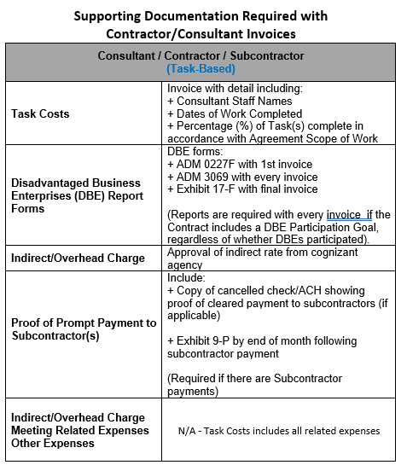

EXHIBIT J

CERTIFICATION OF RESTRICTIONS ON LOBBYING
(For agreements exceeding $100,000)

I, __________________________, hereby certify on behalf of _____________________________________ that
(name and title of official) (name of Contractor)

- No Federal appropriated funds have been paid or will be paid, by or on behalf of the undersigned, to any person for influencing or attempting to influence and officer or employee of any agency, a Member of Congress, an officer or employee of Congress, or any employee or a Member of Congress in connection with the awarding of any Federal contract, the making of any Federal grant, the making of any Federal loan, the entering into of any cooperative agreement, and the extension, continuation, renewal, amendment, or modification of any Federal contract, grant, loan, or cooperative agreement.
- If any funds other than Federal appropriated funds have been paid or will be paid to any person for influencing or attempting to influence an officer or employee of any agency, a Member of Congress, an officer or employee of Congress, or an employee of a Member of Congress in connection with this Federal contract, grant, loan, or cooperative agreement, the undersigned shall complete and submit Standard Form-LLL, "Disclosure Form to Report Lobbying," in accordance with its instructions.
- The undersigned shall require that the language of this certification be included in the award documents for all sub-awards at all tiers (including subcontract, sub-grants, and contracts under grants, loans, and cooperative agreements) and that all sub-recipients shall certify and disclose accordingly.
For purposes of this Certification, this Agreement resulting from this RFP shall be considered a federal contract. This certification is a material representation of fact upon which reliance is placed when this transaction was made or entered into. Submission of this certification is a prerequisite for making or entering into this transaction imposed by section 1352, title 31, U.S. Code. Any person who fails to file the required certification shall be subject to a civil penalty of not less than $10,000 and not more than $100,000 for each such failure.

Executed this _______ day of ___________________________.

By __________________________________
(Signature of authorized official)
__________________________________
(Title of authorized official)

Reverter clause and related language to be used only when it is determined that such a clause is necessary in order to effectuate the purposes of Title VI of the Civil Rights Act of 1964.
Reverter clause and related language to be used only when it is determined that such a clause is necessary in order to effectuate the purposes of Title VI of the Civil Rights Act of 1964.

